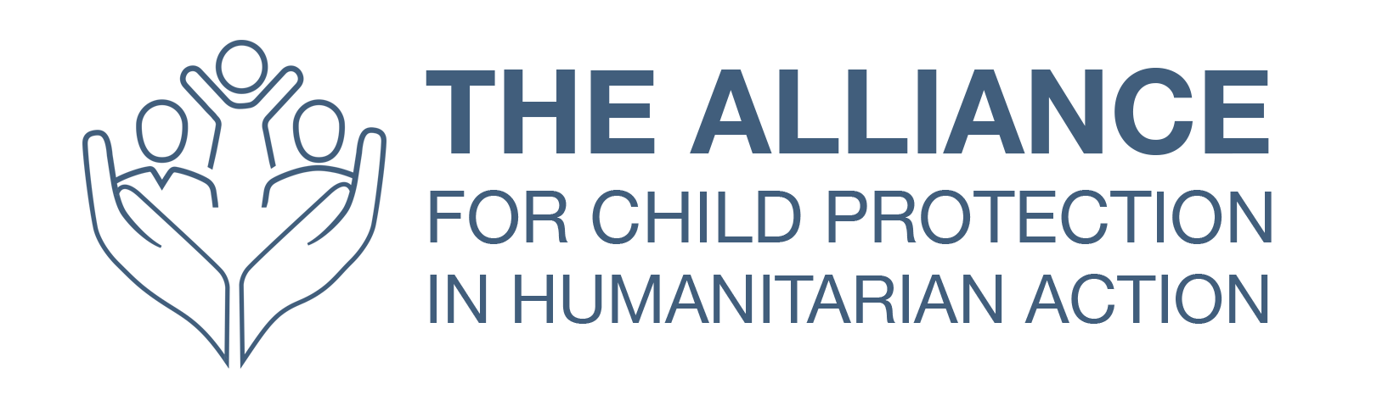

Advocacy Strategy Template

Introduction
Provide a sentence on the issue and why it is important to address. Outline what does this document cover and who is it for.

Context
Include a description of the context in which the advocacy actions will take place - think about some of the challenges and opportunities within the context which have a direct impact on advocacy efforts and must be taken into consideration in the planning.

Objectives
Outline a few well defined objectives for the advocacy. When developing these, think about the tangible changes you want to see as a result of the advocacy. They should be SMART (specific, measurable, achievable, realistic and time-bound).
It might also be helpful to include sub-objectives that indicate milestones along they way to achieving the overall objectives.

Who holds the power / Theory of change
Include here an analysis of who holds the power to make decisions to achieve your objectives.

Key targets
Identify who the targets are for advocacy. Be as specific as possible. If the list is long, it might help to split into the primary targets (these are the top priority targets through which change can be realised) and secondary targets (think here about 'influencers' who can influence the decision makers identified as primary targets).

Primary

Secondary

Key allies
Building on from the power analysis, identify who are your key allies to reach the objectives and collective voices and action might better influence the identified targets. Identifying allies will in turn help in defining the type of activities and events.

Tactical approaches
Develop a list of the key tactical approaches to be employed across the advocacy efforts to maximize the impact, credibility, stakeholder buy-in , and ensure efficient use resources when implementing the strategy. This might be things such as ensuring a platform for community voices in approach and/or centering advocacy and policy recommendations around research and evidence and/or ensuring a platform for children and youth where safe to do so.

ANNEX 1: Key questions for conducting and advocacy strategy brainstorming session
Understanding the situation and reaching the audience | - What do we want?  - Who can make it happen?  - What do they need to hear?  - Who do they need to hear it from?
Identify processess and recognise capacities | - How can we make sure they hear it?  - What do we have?  - What do we need?
Develop a strategic advocacy plan | - How do we begin taking action?  - How can we tell if it is working?

ANNEX 2: Advocacy Planning
Use/adapt the table to identify the specific activities that will be conducted. Think about how different channels can relate to or reach they key targets listed above. Can include launch events, webinars, round table discussions, podcasts, blogs, press-releases etc.
Type of event /  product / initiative | Objective it links to | Target audience | Description | Timeframe

Examples of tactics
- Holding a meeting with key decision makers (could be authorities, or local MP or national MP for example or with members of the Humanitarian Country Team if the context has one)
- Hold a consultation with key members of the community, including children (where safe and appropriate) to understand the key issues for them and what they would like to see advocated on. This can help inform development of an advocacy strategy and build relationships.
- Writing a letter (public or private) - can also be a joint letter with other organisations
- Preparing an advocacy briefing on the key issues and recommendations (Can be public or private) to share with those that can influence change (local authorities, community leaders, influential donors / governments)

ANNEX 3: Overview of Advocacy Findings, Messages and Recommendations
In this final section, including an overview of the key findings, messages and recommendations which form the content of the advocacy efforts. This can be a summary of a longer report or research, but its good to have them here as a reference.
Key findings

Key messages

Call to action/recommendations

